**TRAFFIC MANAGEMENT**

**Team members:**

AU910421106004-Bharathi.G

AU910421106007-T.G.Hraiharan

AU910421106018-S.Ragulkrishnan

AU910421106027-S.Surenthiran

An IoT (Internet of Things) traffic monitoring system is a network of interconnected devices and sensors that collect data about traffic conditions. These devices can include cameras, traffic lights, vehicle sensors, and more. The system collects real-time data and can be used for various purposes, such as traffic management, congestion detection, and providing data for smart city initiatives.

**Sensors:** These can include cameras, radar, LiDAR, infrared sensors, and vehicle detection loops embedded in the road. These sensors collect data on vehicle movement, speed, and traffic flow.

**Communication Infrastructure**: IoT devices use wireless technologies like Wi-Fi, cellular networks, or Low Power Wide Area Networks (LPWAN) to transmit data to a central server or cloud-based platform.

**Data Processing and Analysis:** The collected data is processed and analyzed to generate real-time traffic information, including congestion levels, average speeds, and traffic patterns.

**Cloud Platform**: Data is often sent to cloud-based platforms for storage and analysis. Cloud computing allows for scalable processing and storage of large volumes of data.

**Central Control Center**: Traffic management personnel can access the data and make real-time decisions based on the information provided by the system.

**User Interface:** Users, such as commuters or traffic management personnel, can access traffic information through web or mobile applications.

**Alerts and Notifications**: The system can provide automated alerts and notifications to inform authorities and users of traffic incidents, accidents, or road closures.

**Machine Learning and AI:** Advanced systems may use machine learning and artificial intelligence to predict traffic patterns, optimize traffic signal timings, and provide intelligent recommendations for congestion management.

These systems help improve traffic flow, reduce congestion, and enhance overall road safety. They are an integral part of smart city initiatives aimed at optimizing transportation and enhancing the quality of urban life.

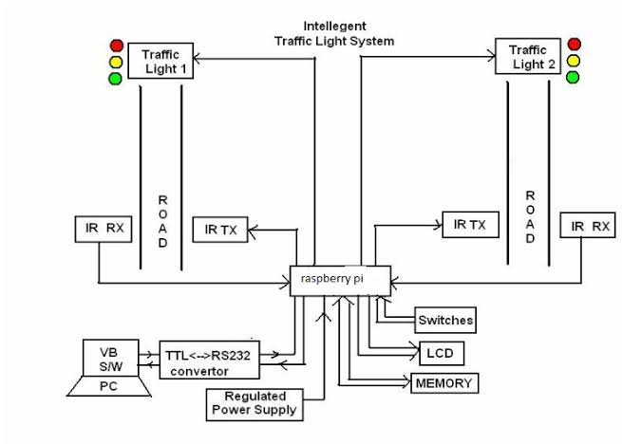

**Program:**

import random

import time

class TrafficSensor:

def _init_(self, location):

self.location = location

def measure_traffic(self):

# Simulate traffic data, replace this with actual sensor readings

return random.randint(0, 100)

class TrafficMonitoringSystem:

def _init_(self):

self.sensors = [TrafficSensor("Intersection1"), TrafficSensor("Intersection2")]

def monitor_traffic(self):

while True:

for sensor in self.sensors:

traffic_data = sensor.measure_traffic()

print(f"{sensor.location}: Traffic - {traffic_data} vehicles")

# Add code to send data to a central server or perform further analysis

time.sleep(5) # Simulate a delay between measurements

if _name_ == "_main_":

traffic_system = TrafficMonitoringSystem()

traffic_system.monitor_traffic()